Application Number | 07/2019/8177/ADV
Address | Land at School Lane and Golden Hill Lane  Leyland
Applicant | Aldi Stores Ltd

Agent Harris Partnership
77 Dale Street
Manchester
Development | Advertisement consent for 5 no. internally illuminated signs
Officer Recommendation | Consent Granted with Conditions

Date application valid | 20.8.19
Target Determination Date | 15.10.19
Extension of Time | 25.10.19

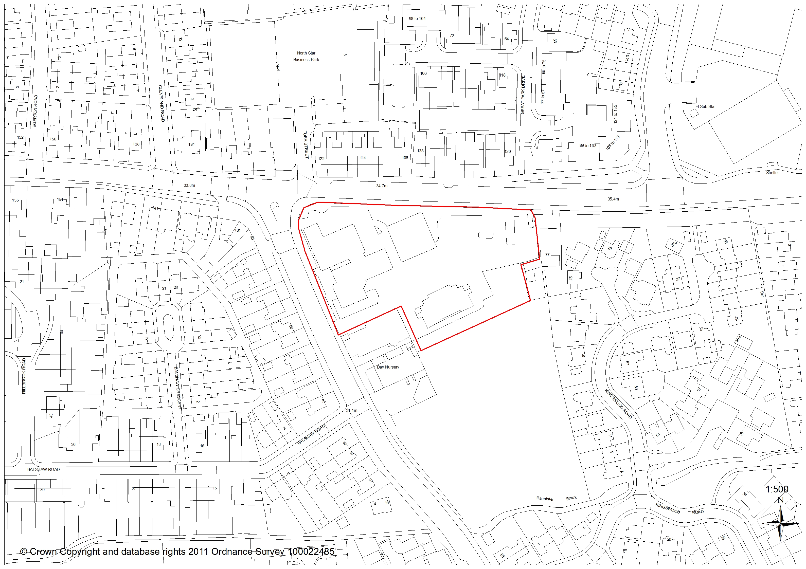

- Report Summary

  - The application seeks advertisement consent for a recently approved, but unconstructed food store accessed off School Lane, Leyland. The application proposes erection of 5 no: illuminated signs; four on the approved store and 1 no: totem to be located within the site but towards the School and Golden Hill Lane junction.

  - At the time of writing this report six letters of objection have been received – both with regards to proposed advertisement and the approved store. Lancashire County Council however do not objection to either signage or illumination on highways safety grounds.

  - Having regard to the following report, it is recommended that consent is granted subject to the imposition of conditions.

- Application Site and Surrounding Area

  - The proposal site is a 0.7ha piece of land at the junction of Golden Hill and School Lanes, Leyland. Golden Hill Lane runs in an east to west direction along the sites northern edge, whilst School Lane spans the western boundary.

  - Immediately across Golden Hill Lane are no’s 120-138 Great Park Drive and 106-124 Golden Hill Lane, and facing in the west are no’s 45-65 School Lane and 131 Golden Hill Lane. 77 Golden Hill Lane (commercial) abuts the eastern site boundary, with no’s 25-27 Kingswood Road behind this property, and in the south is Stonehouse Nursery (Grade II listed).

  - The site and immediate surroundings are designated by Policy B1 (Existing Built Up Area) of the South Ribble Local Plan.

- Site Context / Planning History

  - There are 36 planning applications on the sites history most of which pre-date 1999 and relate to the previous use.

  - The only application of relevance to this proposal is 07/2018/8309/FUL granted for erection of single storey foodstore (Class A1) with associated works and car parking following demolition of existing buildings. Approved by Committee May 2019

- Proposal

  - The application proposes erection of 5 no: internally illuminated signs; all to be in the standard Aldi corporate livery:

  - Signs 1-3: Illuminated, wall mounted fascia signs measuring 2.1m x 2.5m high. To be located above the front elevation facing the access way (4.5m high), on the north-eastern rear corner facing Golden Hill Lane (1.4m high) and on the north-western corner facing the main car park (2.3m high).

  - Sign 4: 1.3m x 1.5m high, and standing 0.5m from ground level on the front elevation

  - Sign 5: Pole mounted totem sign of 2.5m wide x 6m high, with an illuminated sign of 2.1m x 2.5m standing 3.5m from ground level. The totem would be located at the north-western junction of Golden Hill and School Lane. This sign has been relocated from its original School Lane location following comments made at the residents meeting of the 12th August 2019.

- Summary of Supporting Documents

  - The application is accompanied by the following:

- Application form (luminance levels detailed)
- Proposed site plan 2259BOL-1001 Rev A (Harris Partnership)
- Totem Details 2259BOL-1004 (Harris Partnership)
- Signage details 2259BOL-1003 (Harris Partnership)
- Location Plan 2259BOL-1000 (Harris Partnership)
- Proposed elevations 2259BOL-102 Rev A and

- Representations

  - Summary of Publicity

    - A site notice has been posted and fifty one properties consulted. Two additional rounds of consultation occurred following amendments, and Ward Councillors Forrest and Bylinski-Gelder have been notified. Comments received from six residents are summarised as:

- The site will be intrusive enough without illuminated signs
- Impact of lighting on residents/lost residential amenity – ‘area is residential as all industrial sites have now been built on’
- No need for lighting – ‘the store will be visible enough’
- Increase in lighting as previous site use was dark at night – although the site had been in daytime use for some time it benefits from lawful 24hr use and could revert to these times at any stage
- Out of character/visual impact
- Existing store only has 2 signs and Morrison’s only have 1 sign – a check of both sites notes that the Towngate Aldi store has 3 signs (illuminated fascia on Towngate/ illuminated totem signs over main entrance and at corner of Westgate/Towngate). Morrison’s have illuminated fascia signs on the side and front elevations (4 in total) and an illuminated totem facing Golden Hill Lane in addition to numerous signs on the adjacent petrol station.
- Respondent agrees to 1 no: unlit sign only
- Lighting will invoke headaches and migraines amongst residents
- Request that the applicant relocates the sign to School Lane

Comments which relate solely to the approved use of the site and as such have not been given consideration are:

- Increased traffic and pollution
- Loss of old St Marys building and impact on Old School House if surrounded by new buildings
- Too many supermarkets
- Council impotence at allowing supermarket in this location
- Loss of amenity resulting from car and site lighting
- The area is ‘residential not Piccadilly Circus’
- Lost tree
- Aldi promised community benefits but this property is not a benefit to adjacent residents

- Summary of Responses

  - Lancashire County Council Highways have no objection on highways safety grounds. A condition to restrict luminance levels is standard practice for signage of this type, and is recommended should consent be granted.

- Material Considerations

  - Relevant Policy

    - The site is designated under Policy B1 of the South Ribble Local Plan as Existing Built Up Area which includes a presumption towards re-development of under used sites where proposals do not impact upon the amenity of occupants of the area, highways safety or the areas character.

  - Additional Policy Background

Additional policy of marked relevance to this proposal is as follows:

    - Economic Policy

        - The National Planning Policy Framework (2019) provides a presumption in favour of sustainable economic growth and development, with Chapter 6 (Building a strong, competitive economy) committing to economic growth, job creation and prosperity in order to meet the challenges of competition, whilst ensuring that the planning system does everything it can to support sustainable economic growth (Para 80). Core Strategy Policy 11 (Retail and Town Centre Uses) reflects these sentiments

    - Design/Highways Policy

        - Core Strategy Chapter 7 (Requiring Good Design) and Local Plan Policy G17 (Design of New Buildings) each attach great importance to the design of the built environment to ensure that proposals relate well to neighbouring buildings and the locality, and would not prejudice highway and pedestrian safety, or the free flow of traffic.

  - Other Material Considerations

    - Area Character and Impact Upon Residential Properties

        - The School/Golden Hill Lane area of Leyland is characterised by a range of properties in mixed use (commercial and residential), style, height and age and although relatively traditional there is no defined vernacular to the locality. Existing buildings within the site are on the one hand 1970’s utilitarian buildings and on the other C18th and C19th, more decorative structures.

        - The previously approved Aldi store was considered by Members to be of high quality design with appropriate landscaping which related well to neighbouring buildings and the extended locality. By approving such a development, it is therefore not unrealistic for the applicant to seek permission for accompanying advertisement as found outside retail outlets across the country.

        - Proposed signage would be screened in part by existing and proposed boundary treatments, and in the case of three signs would face towards the proposed store car park.

        - The totem would face towards Golden Hill Lane in the west and east; its 400mm wide, side view being at right angles to, and 23m from the closest property on Golden Hill Lane (no: 122). Neighbouring dwellings (no’s 106-120 & 126 Golden Hill and 120-138 Great Park Drive) would indirectly face the sign at between 23m and 100m distance. In the west the totem would face retail premises across School Lane at around 35m; all retail properties on this side have illuminated signage. The closest dwelling on School Lane is no: 61 which benefits from 40m separation.

        - Proposed signage on the stores rear elevation would face dwellings in the north across Golden Hill Lane at 23m – 25m separation, whilst signs attached to the side and front elevations would enjoy a minimum of 60m distance to neighbouring buildings with appropriate landscape screening. To put this into perspective, only 21m is generally required between the habitable room windows of directly facing dwellings, where loss of amenity – including amongst other things from internal and security lighting - is considered unlikely. The case for residential amenity therefore must be taken in context when considering proposed separation distances and the presence already of illuminated signage elsewhere; including on School and Golden Hill Lanes.

- Conclusion

  - Proposed signage is, by necessity, prominent. It is however similar to other retail premises in the area – including 4 shops facing on School Lane and a small industrial park opposite on Golden Hill Lane. Signage replicates that found on food stores in Leyland and further afield, and subject to a condition to restrict levels of luminance would not impact so detrimentally on highways safety, the character of the area or residential amenity as to warrant refusal

  - Many of the objections raised refer to the previously approved store proposal. As the principle of development is now established these have not been taken into account. Having regard solely to the advertisement scheme therefore, the proposal is considered to accord with relevant policies of the South Ribble Local Plan 2012-2026 and is therefore recommended that consent is granted subject to the imposition of conditions.

RECOMMENDATION:

Grant consent with conditions

RECOMMENDED CONDITIONS:

1. The development hereby permitted must be begun not later than the expiration of three years beginning with the date of this permission.
REASON: Required to be imposed pursuant to Section 91 of the Town and Country Planning Act 1990.

2. The development hereby permitted shall be carried out in accordance with the following approved plans and suite of documents:
      - Application form (luminance levels detailed)
- Proposed site plan 2259BOL-1001 Rev A (Harris Partnership)
- Totem Details 2259BOL-1004 (Harris Partnership)
- Signage details 2259BOL-1003 (Harris Partnership)
- Location Plan 2259BOL-1000 (Harris Partnership)
- Proposed elevations 2259BOL-102 Rev A and
REASON: For the avoidance of doubt and to ensure a satisfactory standard of development in accordance with Policy 17 of the Central Lancashire Core Strategy and Local Plan 2012-2026 Policy G17

3. The limits of luminance shall not exceed those described in Paragraph 2 of Schedule 3 Part II of the Town and Country Planning (Control of Advertisements) Regulations 2007 No 783.
REASON: To avoid glare, dazzle or distraction to passing motorists

RELEVANT POLICY

National Planning Policy Framework

Central Lancashire Core Strategy
11 Retail and Town Centre Uses and Business Based Tourism
17 Design of New Buildings

South Ribble Local Plan
B1 Existing Built Up Area
G17 Design Criteria for New Development

